1. Tabel User

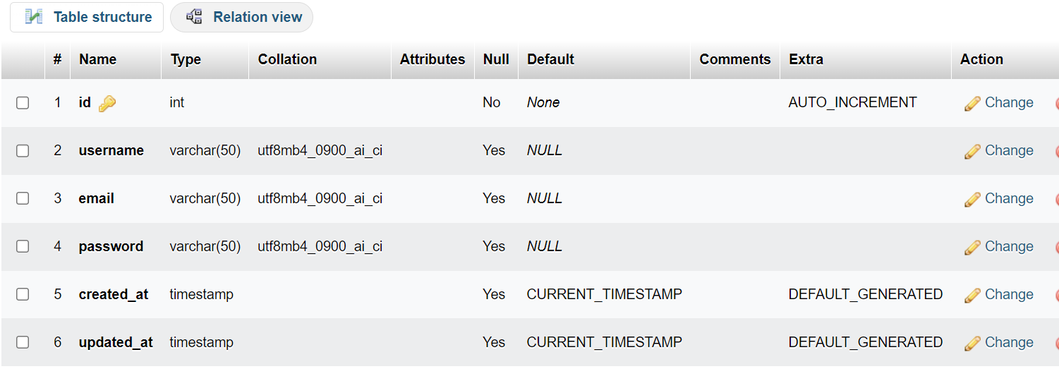

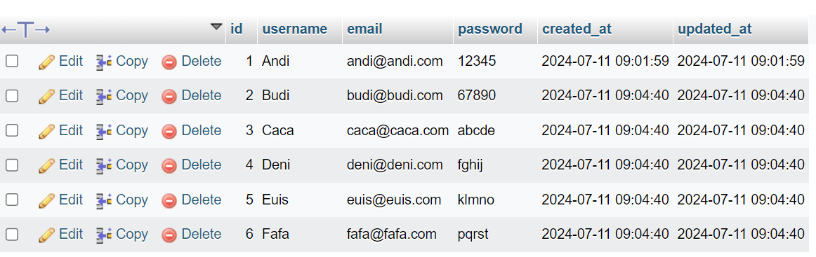

1. Tabel Course

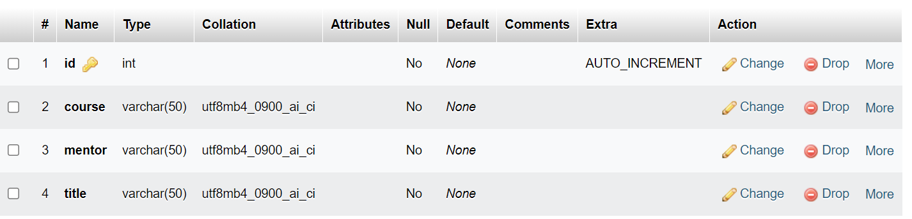

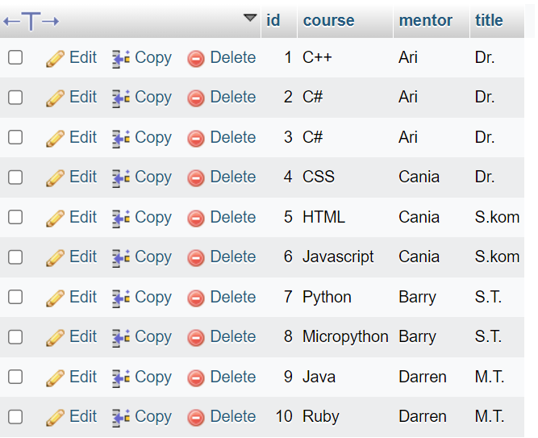

1. Table userCourse

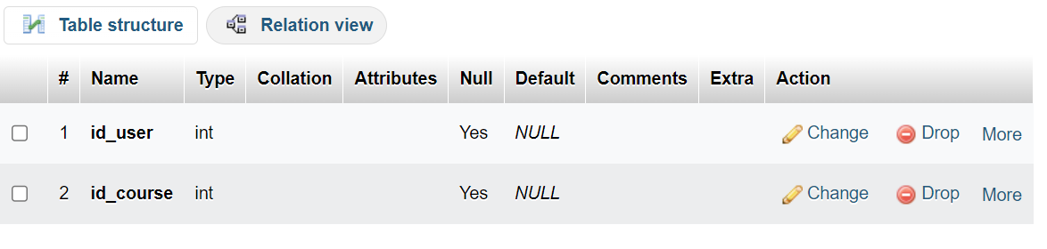

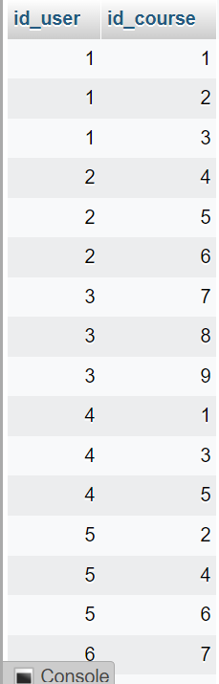

1. tampilkan semua daftar peserta didik beserta mata kuliah yang diikutinya

[SELECT](http://localhost/phpmyadmin/url.php?url=https://dev.mysql.com/doc/refman/8.0/en/select.html) C.id, C.username, B.course, B.mentor, B.title FROM usercourse A [LEFT](http://localhost/phpmyadmin/url.php?url=https://dev.mysql.com/doc/refman/8.0/en/string-functions.html%23function_left) JOIN courses B ON A.id_course=B.id [LEFT](http://localhost/phpmyadmin/url.php?url=https://dev.mysql.com/doc/refman/8.0/en/string-functions.html%23function_left) JOIN users C ON C.id=A.id_user;

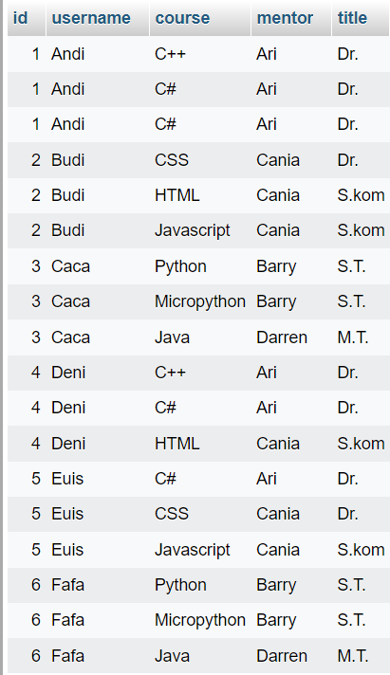

1. tampilkan daftar peserta didik beserta mata kuliah yang diikutinya

[SELECT](http://localhost/phpmyadmin/url.php?url=https://dev.mysql.com/doc/refman/8.0/en/select.html) C.id, C.username, B.course, B.mentor, B.title FROM usercourse A [LEFT](http://localhost/phpmyadmin/url.php?url=https://dev.mysql.com/doc/refman/8.0/en/string-functions.html%23function_left) JOIN courses B ON A.id_course=B.id [LEFT](http://localhost/phpmyadmin/url.php?url=https://dev.mysql.com/doc/refman/8.0/en/string-functions.html%23function_left) JOIN users C ON C.id=A.id_user WHERE B.title [LIKE](http://localhost/phpmyadmin/url.php?url=https://dev.mysql.com/doc/refman/8.0/en/string-comparison-functions.html%23operator_like) 'S.%';

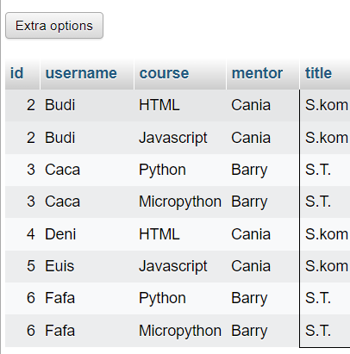

1. tampilkan daftar peserta didik beserta mata kuliah yang diikutinya, yang mentornya bergelar selain sarjana.  
   [SELECT](http://localhost/phpmyadmin/url.php?url=https://dev.mysql.com/doc/refman/8.0/en/select.html) C.id, C.username, B.course, B.mentor, B.title FROM usercourse A [LEFT](http://localhost/phpmyadmin/url.php?url=https://dev.mysql.com/doc/refman/8.0/en/string-functions.html%23function_left) JOIN courses B ON A.id_course=B.id [LEFT](http://localhost/phpmyadmin/url.php?url=https://dev.mysql.com/doc/refman/8.0/en/string-functions.html%23function_left) JOIN users C ON C.id=A.id_user WHERE B.title [NOT](http://localhost/phpmyadmin/url.php?url=https://dev.mysql.com/doc/refman/8.0/en/logical-operators.html%23operator_not) [LIKE](http://localhost/phpmyadmin/url.php?url=https://dev.mysql.com/doc/refman/8.0/en/string-comparison-functions.html%23operator_like) 'S.%';

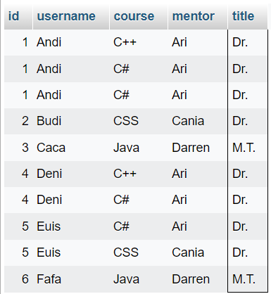

1. tampilkan jumlah peserta didik untuk setiap mata kuliah.  
   [SELECT](http://localhost/phpmyadmin/url.php?url=https://dev.mysql.com/doc/refman/8.0/en/select.html) B.course, B.mentor, B.title, [COUNT](http://localhost/phpmyadmin/url.php?url=https://dev.mysql.com/doc/refman/8.0/en/aggregate-functions.html%23function_count)(*) AS jumlah_peserta FROM usercourse A [LEFT](http://localhost/phpmyadmin/url.php?url=https://dev.mysql.com/doc/refman/8.0/en/string-functions.html%23function_left) JOIN courses B ON A.id_course = B.id [LEFT](http://localhost/phpmyadmin/url.php?url=https://dev.mysql.com/doc/refman/8.0/en/string-functions.html%23function_left) JOIN users C ON C.id = A.id_user GROUP BY B.course, B.mentor, B.title;

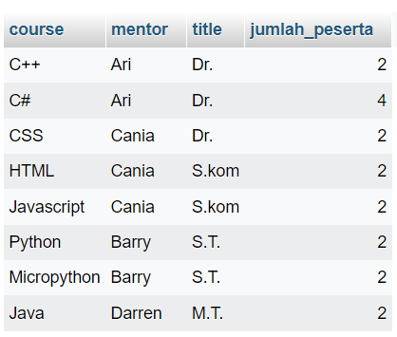

1. tampilkan jumlah peserta didik beserta total fee untuk setiap mentor.

[SELECT](http://localhost/phpmyadmin/url.php?url=https://dev.mysql.com/doc/refman/8.0/en/select.html) B.mentor, [COUNT](http://localhost/phpmyadmin/url.php?url=https://dev.mysql.com/doc/refman/8.0/en/aggregate-functions.html%23function_count)(*) AS jumlah_peserta, [COUNT](http://localhost/phpmyadmin/url.php?url=https://dev.mysql.com/doc/refman/8.0/en/aggregate-functions.html%23function_count)(*) * 200000 AS total_fee FROM usercourse A [LEFT](http://localhost/phpmyadmin/url.php?url=https://dev.mysql.com/doc/refman/8.0/en/string-functions.html%23function_left) JOIN courses B ON A.id_course = B.id [LEFT](http://localhost/phpmyadmin/url.php?url=https://dev.mysql.com/doc/refman/8.0/en/string-functions.html%23function_left) JOIN users C ON C.id = A.id_user GROUP BY B.mentor;

